# Lab: Popular Libraries

Problems for exercises and homework for the “HTML and CSS” course @ SoftUni. Submit your solutions in the SoftUni judge system at <https://judge.softuni.bg/Contests/415/Popular-Libraries> .

## Simple Bootstrap Page

Create a Web page (HTML5 + CSS3 + images) that looks and behaves like the screenshots below:

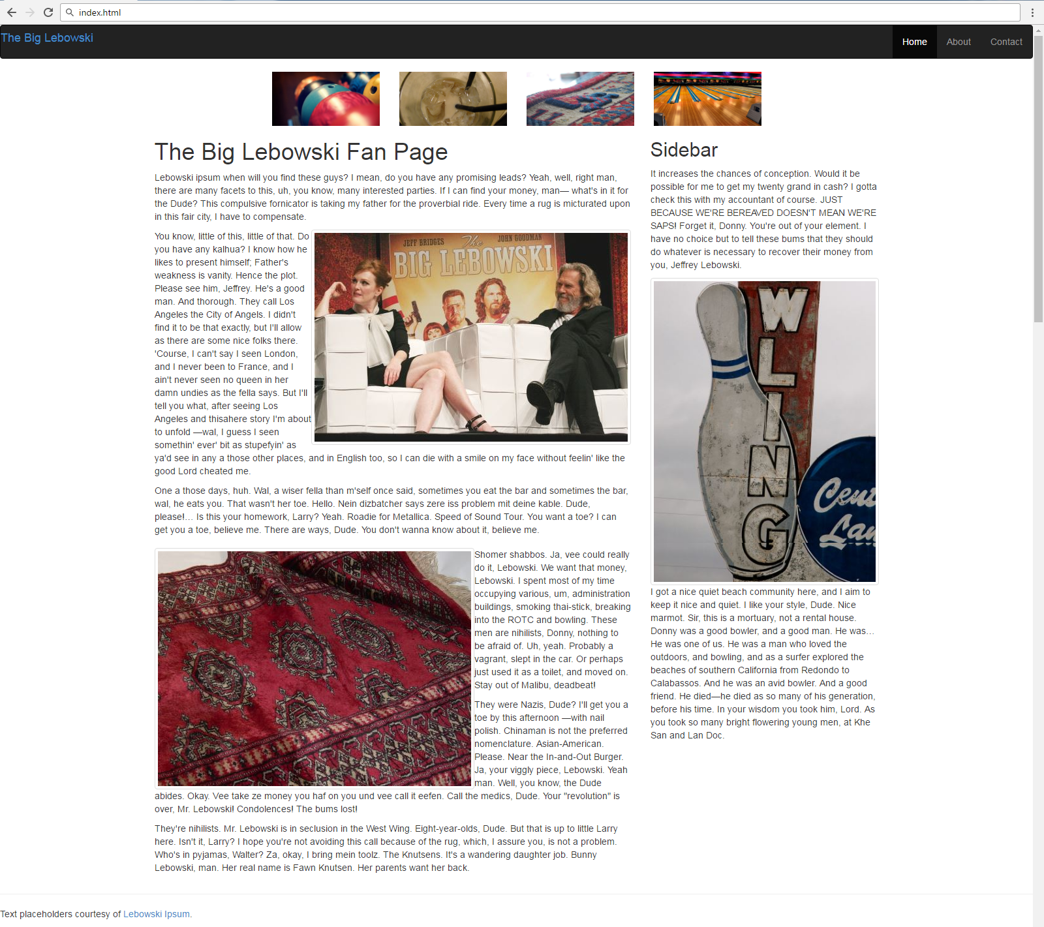

Resolution under **768px**

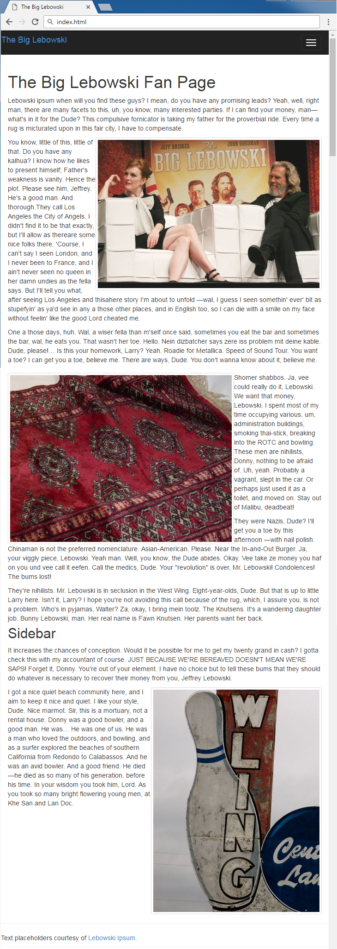

### Steps to Follow

Include bootstrap.min.css, jquery-2.0.3.min.js and bootstrap.min.css in the HTML <head> section:

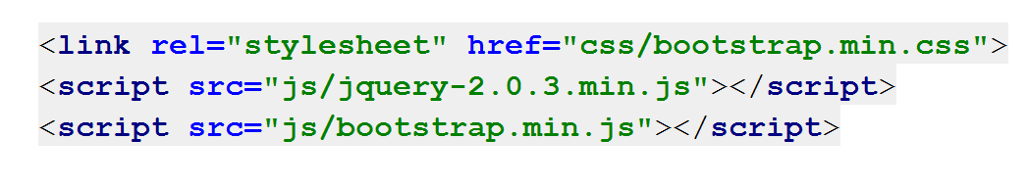

Create and add classes for mobile menu:

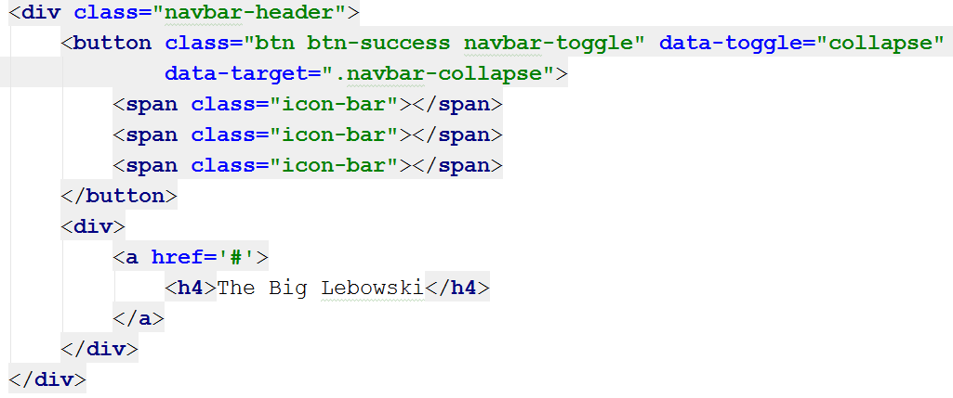

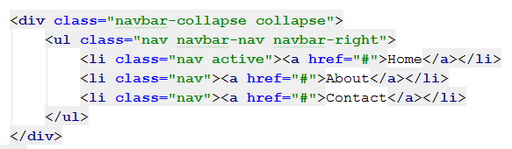

Test the site in the browser:

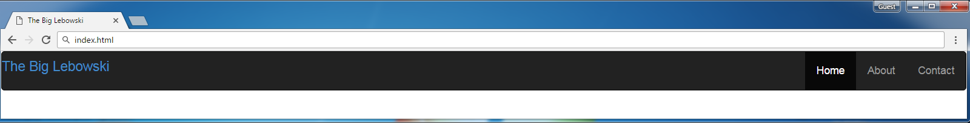

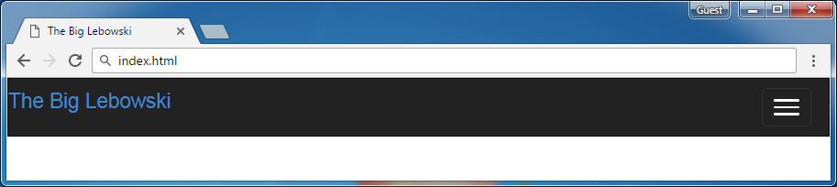

Now make image visible only for medium and large resolution

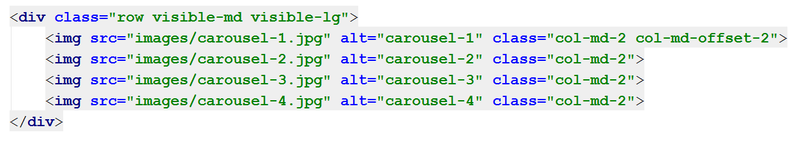

Use bootstrap grid system and add class="col-md-8 col-sm-9" and make image "lebowski-1.jpg" to float right and image "lebowski-3.jpg" to float left and make them responsive with class "**img-thumbnail"**

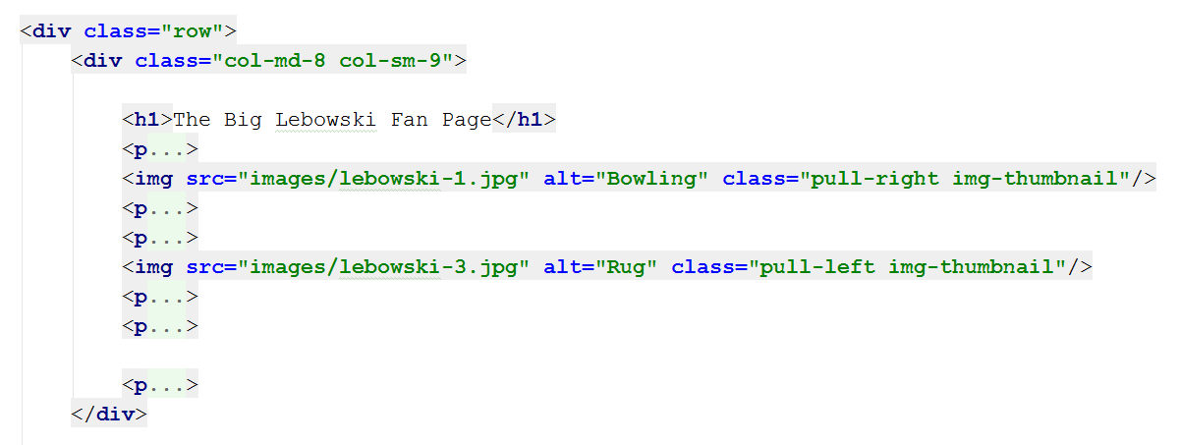

Test in medium resolution from **992px** to **1200px**

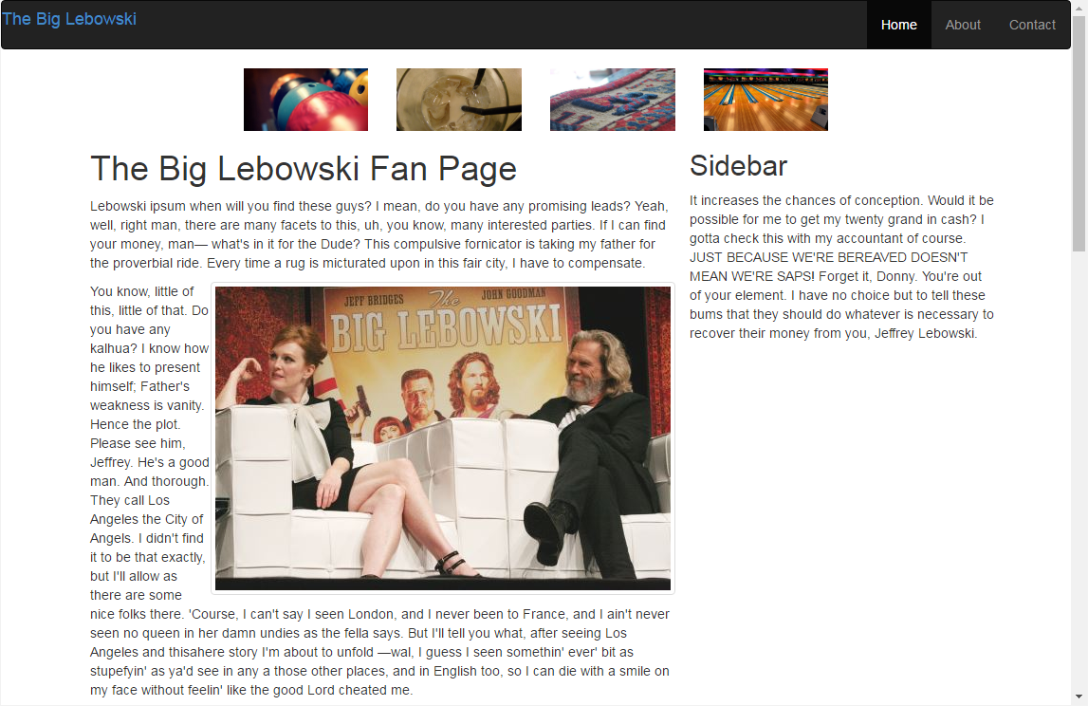

Now style the sidebar

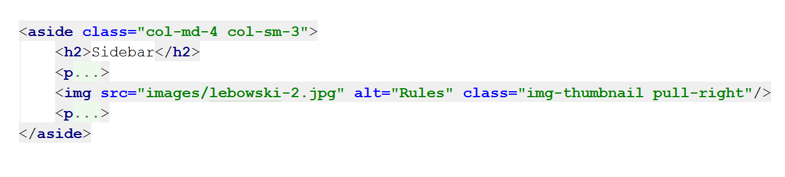

Now test again

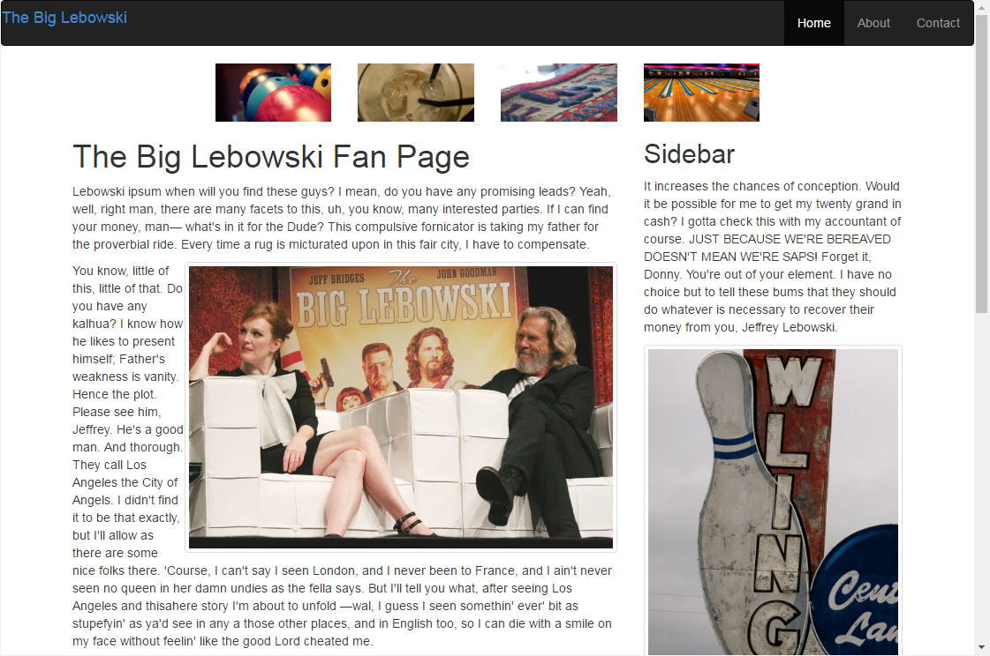

Now style the footer:

